Increment Letter

October 07, 2023

Prashant B. Ratnaparkhi

IT RECRUITER

ASC100027/06

Subject: Increment on Performance

Dear Mr./Ms. Prashant B. Ratnaparkhi

We would like to congratulate you on completion of the One Year with us. We are pleased to inform you of your salary increase effective from October 07, 2023 The amount of your revised **CTC** is **₹INR 2,94,000/-**. We understand that this is a substantial increase in your pay and we appreciate your hard work and dedication to our company.

We also want to take this opportunity to thank you for all of your contributions over the past year. Your performance has been exemplary and we appreciate the valuable advice and guidance you have provided during this period.

Please accept this letter as formal notification of your salary increase and as a gesture of appreciation from the management team at Ascloud Secure.

Best Wishes

For Ascloud Secure

(Authorized Signatory)

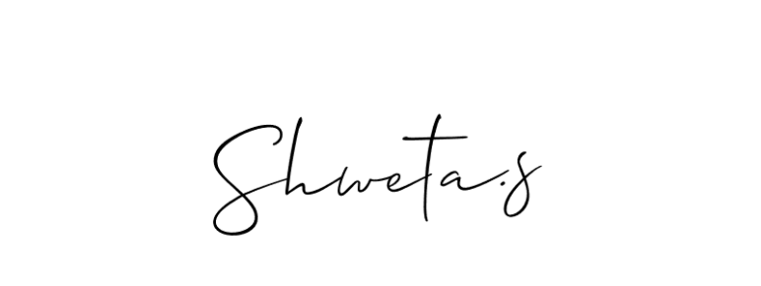

Shweta S.

Manager HR